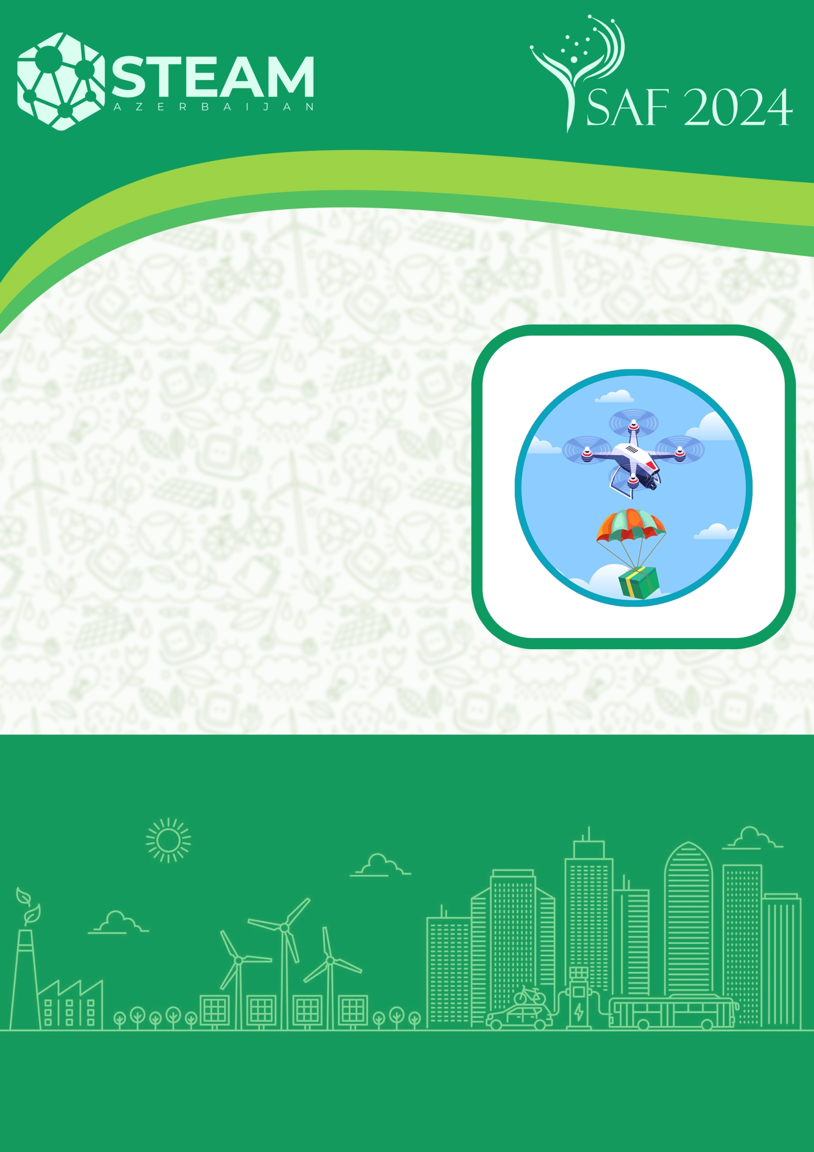
FlyTech
CATEGORY
PRESENTATION OF THE SELECTION STAGE
BAKI 2024

Name of the team:
Name, number and address of the school:
Team leader:
Member 1:
Member 2:
Member 3: (if applicable)

- The peculiarity of the drone
(Here, explain the advantages of the drone you have made, the body materials used, dimensions, weight, etc.)

- Link to drone flight video
(must be video in Youtube format here)

- Team photo
(Here, all team members must have a photo at work or in front of the drone)

- Technical name and pictures of the elements used
  - Motor (name and picture)

  - Propeller (name and photo)

  - Electronic Speed Controller - ESC (name and picture)

  - Battery (name and picture)

  - Flight controller (name and photo)

  - Wireless remote control (name and photo)

  - Servo motor (name and picture)

  - Camera (name and photo)

- Pictures of the drone
  - From the left

  - From the right

  - From the front

  - From behind

  - From above

