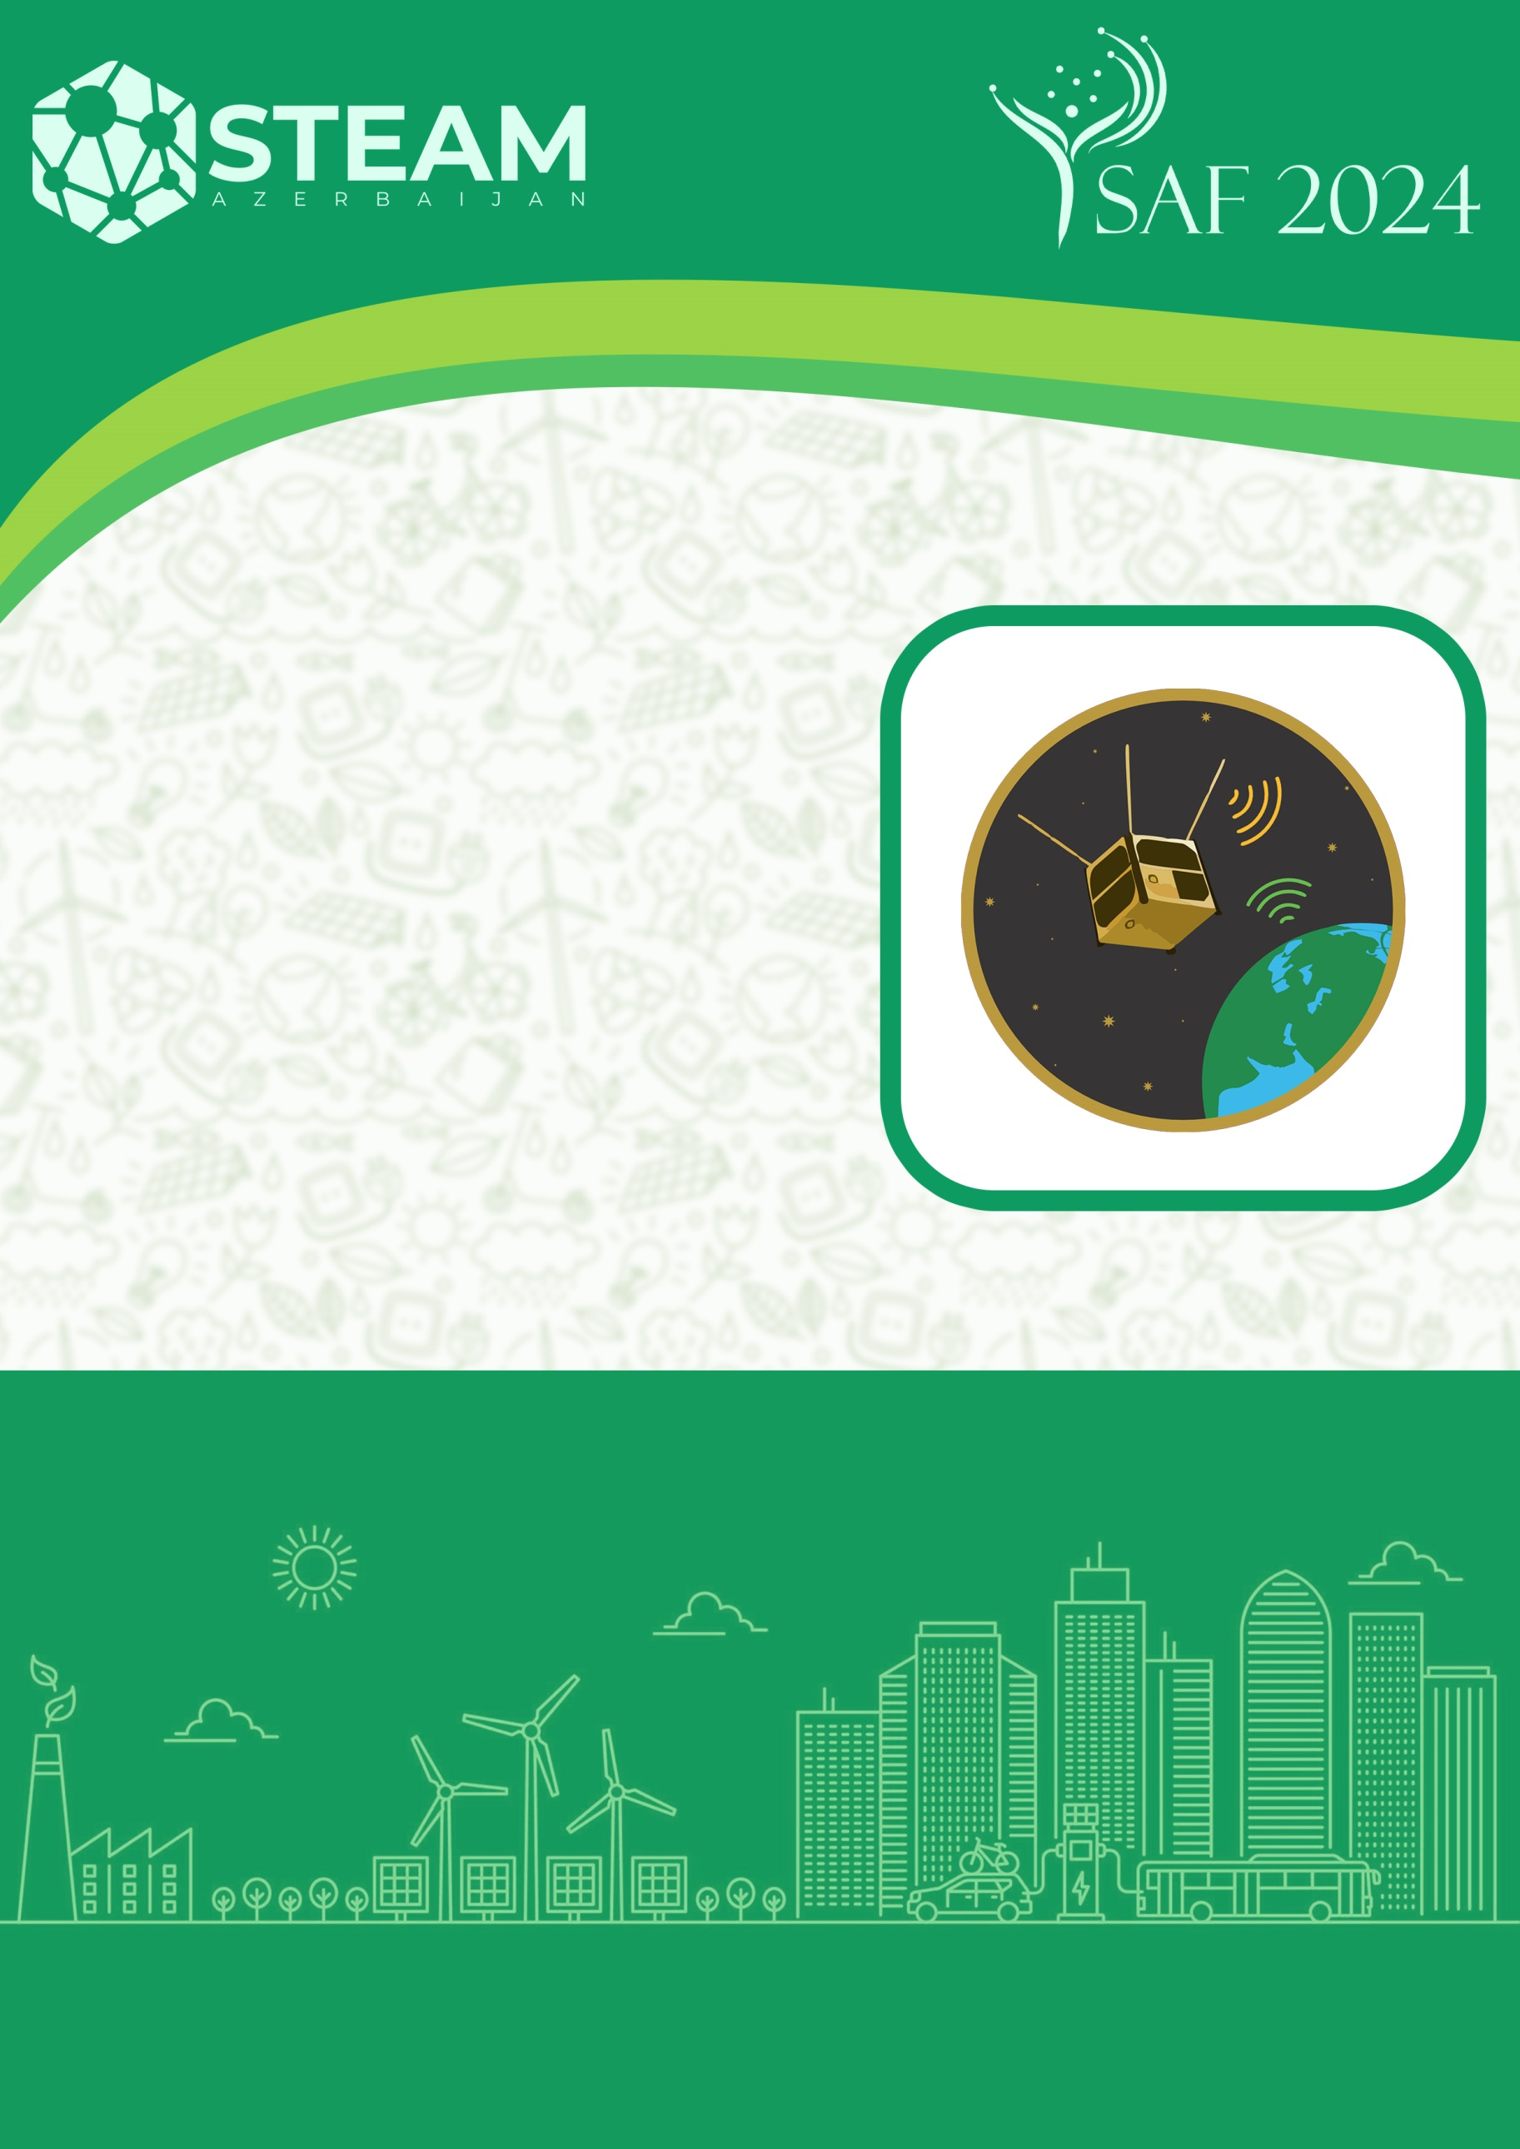
SELECTION PHASE PRESENTATION
BAKI 2024
CubeSat
CATEGORY

Team name:

Name, number and address of the school:

Team leader:

1st student:

2nd student:

- About CubeSat
(Explain the advantages of the elements used in the model made here, the work they do, the design of the CubeSat, its dimensions, weight, etc.)

- Wireless communication with the CubeSat
(There should be a video of the model made here sending data via wireless connection. The video link should be placed here in YouTube format for 60-90 seconds)

- Team photo
(Here, all team members must have a photo at work or in front of the drone)

- Technical name and pictures of the elements used
  - Sensors (names and pictures)
(If more than 1 sensor is used here, the name and picture of each should be mentioned separately)

  - Main controller (name and image)

  - Wireless connection in use (name and image)

  - Design of the CubeSat-body element (image in the design program)

- CubeSat photo images
(Here, each photo should show the size with a ruler next to the model)
  - From the left

  - From the right

  - From the front

  - From behind

  - From above

  - From below

- Photo images of the Satellite Model
  - From the front

  - From above

